*****Deadline December 15th 2022*****
The Bill Mondjack Memorial Scholarship

Objective: The purpose of this scholarship is to aid an individual with real interest in apiculture and to support their involvement and education about apiculture by offering guidance, education, club membership, essential equipment and bees.
Application: Anyone*, age 14-25 years old residing year-round in Pennsylvania’s Lehigh Valley area interested in beekeeping may apply. Preference is given to someone who has a genuine interest in, but no previous experience with beekeeping. The applicant must complete a 1-2 page letter of interest, the online applicant form, a waiver, and a parental consent form (if under the age of 18 years).
Deadline: Annually on December 15 at 5:00 pm
Submit to: beekeepers@lehighvalleybeekeepers.org
Lehigh Valley Beekeepers
P.O. Box 21509
Lehigh Valley, PA
18002

The Award Recipient will Receive:
• A one-year membership in the Lehigh Valley Beekeepers Association (LVBA)
• Registration for the LVBA’s Beekeeping for Beginners course
• Mentoring by a LVBA member for one year
• A complete set of hive equipment for one honey bee colony
• A nucleus colony or 3 lb. package of honey bees for the hive
• A hive tool, in hive frame feeder and bee smoker. Note that personal protective clothing is not included
• Two tickets for the October banquet to allow the recipient and their chosen guest to attend and receive certificate

Eligibility:
1. Applicant must be 14-25 years of age at the time of application.
2. Applicant must reside year-round in PA’s Lehigh Valley area (see map).
3. Applicants under the age of 18 years must have permission and agreement from a parent or guardian.
4. The application, with 1-2 page letter of interest about why the applicant would like to learn beekeeping, must be submitted to the LVBA no later than 5 pm on December 15, 2022.

Award Committee:
1. Finalists will be selected by the LVBA Scholarship Committee.
2. The Committee will arrange an interview by phone or in person with finalists and parents/guardians
3. The certificate of completion will be presented to the selected applicant at the LVBA Fall Banquet in October.

Terms and Conditions of Agreement:
The recipient of this award will be expected to:
1. Attend the Beekeeping for Beginners course
2. Attend at least 50% of the LVBA meetings and apiary outings for one year.
3. Write short reports about their beekeeping adventures for the Association Newsletter
4. Write a final report for display the following year at the October banquet or meeting
Final Report:
In the Fall season after receiving the award, the recipient will submit a final report at the October banquet. This report can be in any form the awardee would like, as long as it is informative. Some examples are 1) an oral presentation, 2) a pre-recorded video presentation that is played, 3) a compilation of photos, notes, and written accounts in the form of a physical or digital scrapbook, 4) an educational children’s book 5) or some other form chosen by the awardee.

At the October club meeting:
A Certificate of Completion and full ownership of the colony and the equipment will be presented at the October meeting if the award recipient has met all terms and conditions. If the recipient no longer desires to keep bees, the Association will retain ownership of the hive, bees, and other equipment.
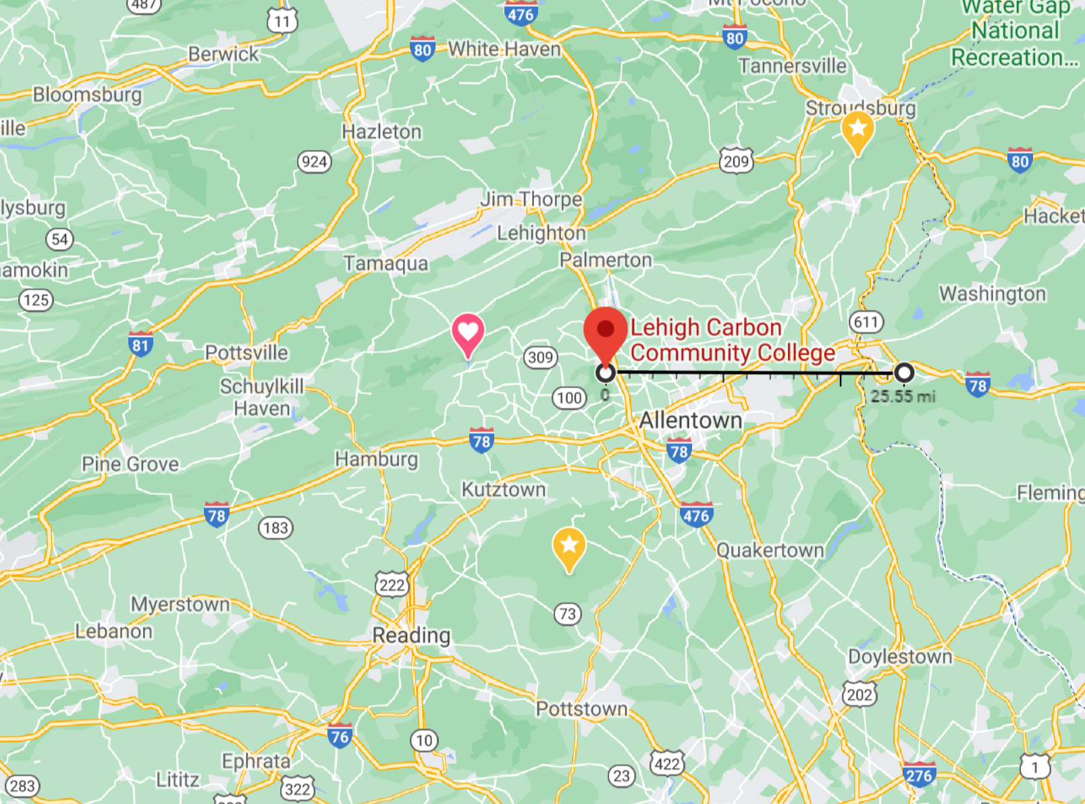
*Applicant cannot be a direct descendant (son/daughter etc….) of a member of the LVBA

